BAHRIA UNIVERSITY (KARACHI CAMPUS)

Assignment 2
CLO 3

Natural language processing

Class: (BSE 7)
Course Instructor: (FAIZ UL HAQUE ZEYA) Time Allowed: 20/12/2023
Date: (3/12/20232 ) Max Marks:5

Student’s Name: Muhammad Muaz Shahzad Reg. No: 02-131202-081



- Write python code for regular expression for following using package re. ( 1 marks)
  - Email address of any type. Domain .com or .edu
  - Karachi or Lahore phone number

Solution

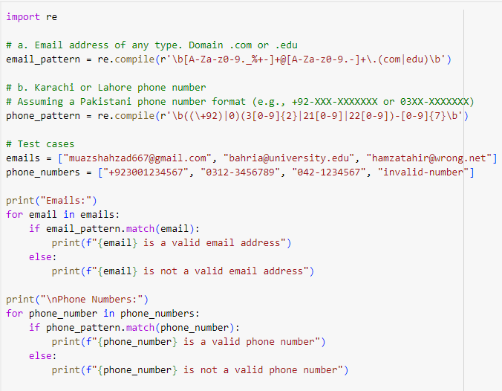

Output

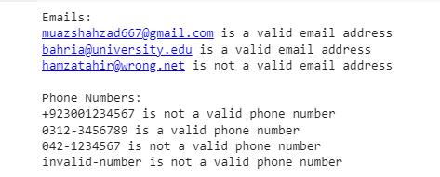

- Write python code for word2vec embedding using any of your text file and find cosine similarity between three pair of word of your choice (both skip gram and CBOW) .Use Gensim library..(2 marks)

Solution

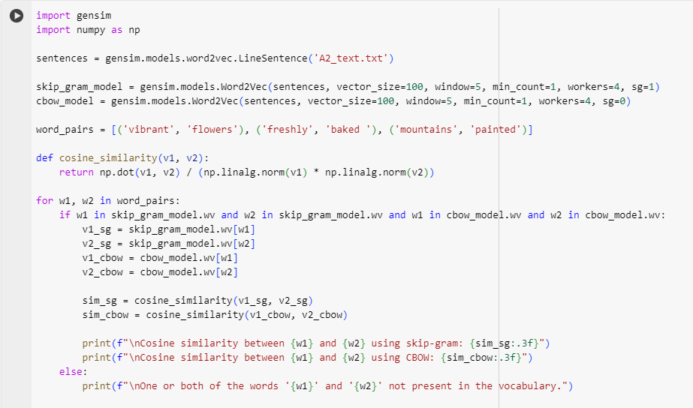

Output

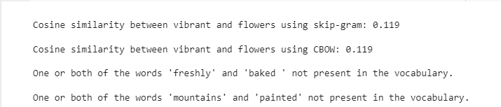

- Use LSTM for sentiment analysis and write python code for it. Use the following link for reference. LSTM Sentiment Analysis | Keras | Kaggle (Don’t copy it) ( 2 marks)

Solution

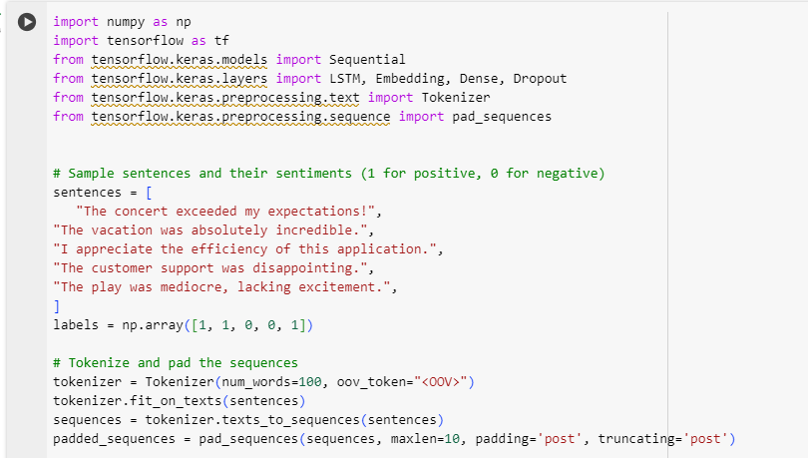

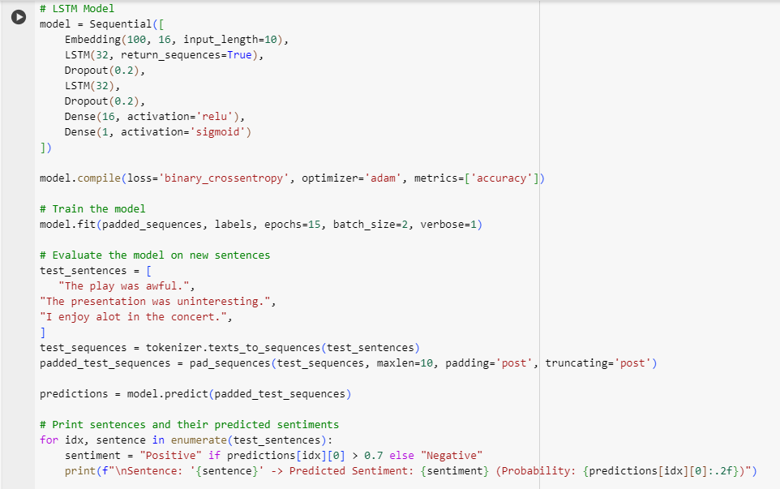

Output:

